

**Student Assistant Application**

**Another Yazan Baniyounes Production**

**Table Of Contents**

Welcome to Student Assistant Application . . . . . . . . . . .(1)

Thank you For Using Student Assistant Application . . . . . . . .(1)

Why Student Assistant Application . . . . . . . . . . . . . .(1)

Exploring the Student Assistant Application Interface . . . .(2)

Main Interface . . . . . . . . . . . . . . . . . . . . . .(2)

File Menu . . . . . . . . . . . . . . . . . . . . . .(5)

Edit Menu . . . . . . . . . . . . . . . . . . . . . .(6)

Language Menu . . . . . . . . . . . . . . . . . . . (14)

Tasks and Tools . . . . . . . . . . . . . . . . . . . . . . .(5)

Load Marks File . . . . . . . . . . . . . . . . . . . . . .(5)

Save Marks File . . . . . . . . . . . . . . . . . . . . . .(5)

backup Marks File . . . . . . . . . . . . . . . . . . . . .(5)

Edit Student Course . . . . . . . . . . . . . . . . . . . . (6)

Show Report . . . . . . . . . . . . . . . . . . . . . . .(8)

Open Estimator . . . . . . . . . . . . . . . . . . . . . (10)

**Welcome to Student Assistant Application**

**Thank you for installing Student Assistant Application**

This user guide will get you started with using Student Assistant Application to manage your works and will introduce you to all the additional features designed to enhance your grades management through your study in the university.

We encourage your active participation and take your feedback seriously, so please let us know how you like Student Assistant Application. You can also contact as at our email yazanse@yahoo.com. 

**Why Student Assistant Application?**

Student Assistant Application helps you manipulate your marks and save them for long use.

With a best-in-class feature set, revolutionary ease-of-use, and none of the traditional pains associated with such assistant software, Student Assistant Application does everything you ever wanted in this field in the way you’ve always prefer to do such thing.

**Exploring the Student Assistant Application Interface**

In The Student Assistant Application (SAA) Features are grouped into task-based menus enables you quickly start using the application.

**SAA Main Interface**

The SAA interface divided into 3 menus. The following describe each menu functionality.

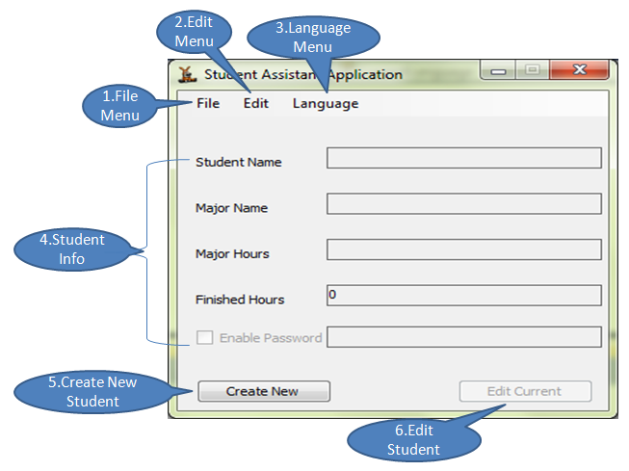

Figure 1-2 : File Menu

1. **File Menu**

The File menu groups common controls to load, save, print and backup marks file.

1. **Edit Menu**

The Edit menu groups command to manipulate marks.

1. **Language Menu**

The Language menu groups all languages that the application support.

1. **Student Information**

Displays the information of the current student that using the application.

1. **Create New**

Create new student that can use the application.

1. **Edit Current**

Edit the current student information that using the application for now.

**Tasks And Tools**

**Load Mark File.**

Use any of the following procedures to load mark file of extension (.mark) .

**1.The File Menu**

1. In the **File** menu, select **Load File**, or press **Ctrl+O**.
2. Navigate to the location of the file you want to load, and select it.
3. Click **Open**.

### 2. Drag-and-drop

1. Open up a Windows Explorer window (**Win key+E**) and locate the Mark file you wish to open
2. Resize your Explorer window to allow your Desktop to show in the background
3. Drag the Mark file from the Explorer window and drop it onto the SAA shortcut.

**Save Marks File**

You can save the current state using file menu or press Ctrl+S.

**Backup Marks File**

You can backup the current file using file menu or press Ctrl+B.

**Edit Student Course**

You can edit current course by choosing **Edit Courses** from the edit menu or press **Ctrl+E.**

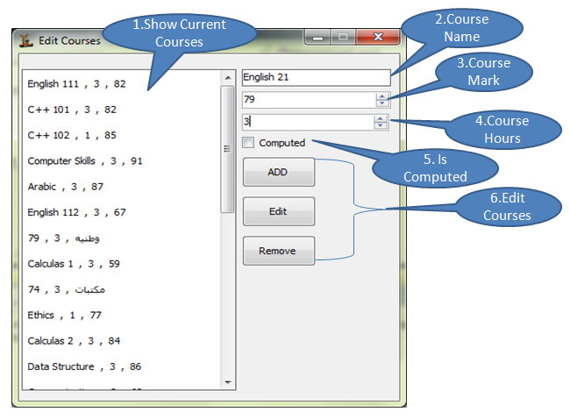

**1.Show Current Course**

A **Display Box** to display the current student courses.

**2.Course Name**

Using to input the current course name.

**3.Course Mark**

Using to input the current course mark.

**4.Course Hours**

Using to input the current course weekly hours.

**5.Is Computed**

Using to identify whether the current course is computed in the total of the student average.

**6.Courses Manipulators**

A three buttons to manipulate current courses

* 1. **ADD** button : Input The Course’s information and then click **ADD**.
  2. **Remove** button : Click on any course in the display box and then click **Remove**.
  3. **Edit** button : Click any course and then click **Edit** and input the course information again at the end click **ADD** then the new information will replace the old ones.

**Show Report**

You can show report containing an information of the student average and marks by choosing **Show Report** from the edit menu or press **Ctrl+H.**

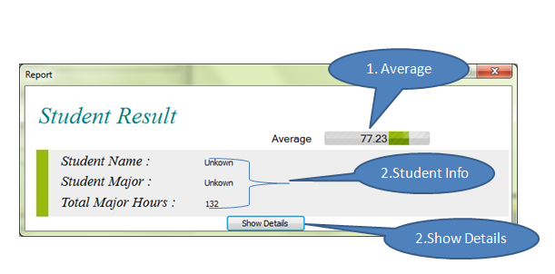

**1.Averge**

Current student average.

**2.Student Info**

A three labels that displays the student information.

**3.Student Info**

A button that used to show more details of about the student marks.

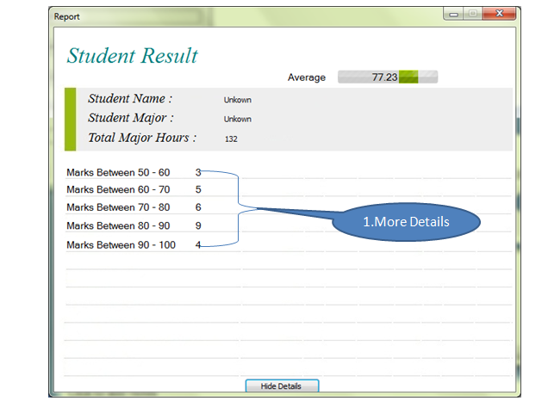

**Open Estimator**

The estimator is a tool that can help you to estimate what is the average that you need to raise your the current average. You can open the estimator by choosing Open Estimator from **Edit Course** menu or press **Ctrl+T.**

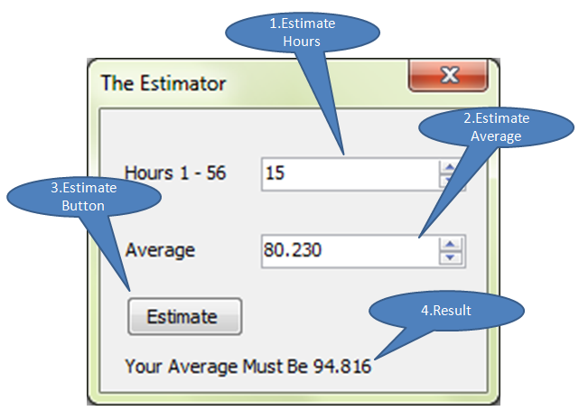

-The following example will Clarify the estimator work:

Let’s assume that your average is 77.3 and you have finished **73** hours and you wandered what’s the average that you need if you want to raise your average to be **80.230** and you have registered **15** hours for the next semester. Then the application will tell you that your average must be for these **15** hours is **94.816.**

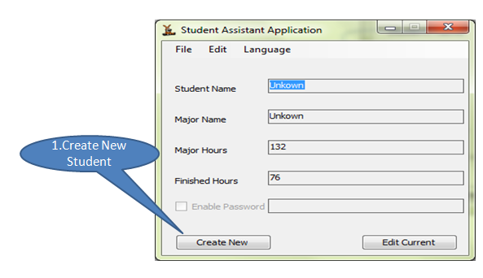

**-**Click the **Create New** and the following window will appear :

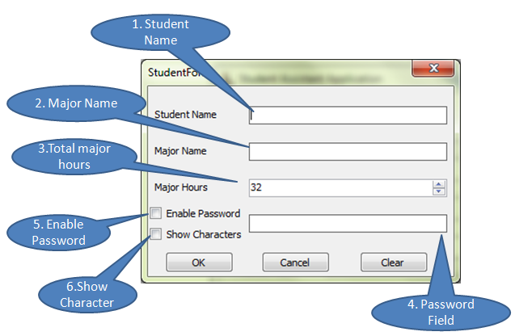

**1.Student Name**

Contains the new student name.

**2.Major Name**

Contains the major name.

**3.Major Hours**

Contains the number of hours you need to finish the major.

**4.Password Field**

Input a password that will protect the student marks file from abuse.

**5.Enable Password**

Enable password protection on the file.

**6.Show Character**

Show the password characters in the password field.

-In the main interface you can click the **Edit Current** to edit the current student information and the following window will appear :

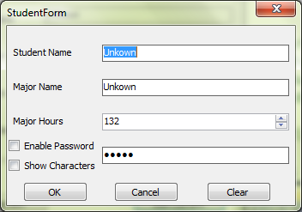

**Language Menu.**

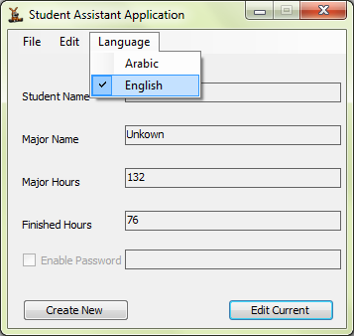

-Two supported languages **Arabic** And **English** click on the language that you want for your application. You have to restart the application to confirm the new language.

At The End : if you exit the application and you have change any of your data then a message box will appear ask you if you want to save your data. Choose **Ok** to save your data , **No** for not or **cancel** to cancel the exit operation.

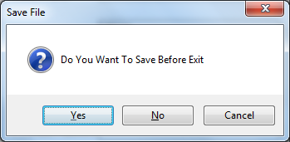

Finally I hope you really enjoyed using the Student Assistant Application and it's really have met your purposes.